**A Radiant Pongal Celebration at Agastya**

Agastya Academy came alive with the memorable Pongal celebration. The sun painted the sky with bright hues, marking the commencement of our festivities. The lively energy of eager KG children, accompanied by our dedicated staff, set the tone. Together, everyone gathered around the tree house, establishing the stage for a day brimming with tradition and unity.

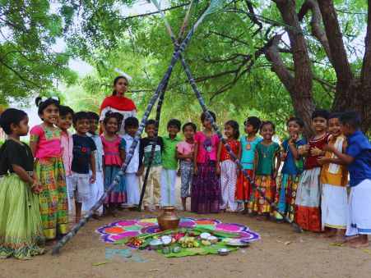

The heart of our celebration began with the age-old tradition of preparing Pongal. The setting was meticulously arranged, with the surroundings swept clean. A big mud pot was placed on a carefully arranged tri-stone stove, awaiting the crackling flames of firewood, ensuring an authentic Pongal-making experience. Dressed in traditional attire, our little boys, sporting matching shirts and white vestis, added a colorful charm to the morning.

[Click here for more……..](https://www.agastyaacademy.edu.in/post/a-radiant-pongal-celebration-at-agastya)